Executive Summary

There are a thousand of laboratory and medical examinations accomplished by Social Hygiene Clinic. But despite these huge numbers, the system of recording and reporting in the facility mainly relies on logbooks and index cards. And with limited manpower, errors made during recording which makes it less efficient and reliable, retrieval of records are also a challenge in the facility. Each time a record is not located, a new record is made which results to multiple records for a single patient. This report describes and evaluates the possible solutions, that can be used by SHC staff to more reliable service. The project aims to develop an electronic clinical database in order to decrease the number of hours spent in recording patient’s information and in generating monthly, quarterly and annual reports. And decrease the time exerted by health staff during retrieval of records of the previous patients. With the help of Electronic Clinical Database recording and reporting in the facility, minimal effort and time are spent as compared with the current paper-based system.

Background

The Sexually Transmitted Infection Control Program is implemented by Social Hygiene Service of the Department of Health. Although it accepts patients from the general population, it mainly caters clients working from night establishments, massage parlors, and other establishments alike. In cooperation with the city health laboratory, the clinic provides services namely Gram-staining (vaginal smearing), urinalysis, fecalysis, Syphilis (RPR) and Hepatitis B Screening. Under the Sanitation Code of the Philippines, night establishment workers including waiters/waitress, room boys, busboys, ushers, bartenders, linen/lady keepers, floor managers, cashiers, bouncers, band singers and receptionists are required to apply for health certificate from the City Health Office and undergo compulsory laboratory examination which include RPR, Gram stain, HBsAg screening test, Urinalysis, Fecalysis, and Chest x-ray which is valid for 1 year. Personnel including receptionists, GRO/hostess, masseurs/therapists/massage attendants, bar girls, dancers/models, disc jockeys, impersonators and make-up artists shall undergo additional gram stain Test done every 2 weeks aside from the routine examination required. Those personnel required to undergo twice a month Gram staining shall possess an up-to-date pink card an updated white card (STI free) secured from the Paranaque City Social Hygiene Clinic. And aside from these services, SHC also specializes on STIs (Sexually Transmitted Infections), assessing and treating walk-in or patient endorse by their respective barangay health centers. Through the SHC, STI detection, treatment and prevention is greatly observed and thus, making it less of a threat for the public health. In addition to SHC’s roles, the clinic also provides seminar and counseling regarding HIV/AIDS, STI and sanitation code. Voluntary HIV counseling and testing is also being offered to those who want to know their HIV-AIDS status.

A review of the Annual Report of the Social Hygiene Clinic and Wellness Center in 2014 showed that the facility accomplished thousands of laboratory and medical examinations including vaginal smears for Gram staining, syphilis screening, Hepatitis B screening, urinalysis examination and examination. But despite these huge numbers, the system of recording and reporting in the facility mainly relies on logbooks and index cards. And with limited manpower, paper-based recording of this vast information entails several hours and not to mention the errors made during recording which makes it less efficient. In addition, retrieval of records was also observed to be one of the major problems in the facility. Each time a record is not located, a new record is made which results to multiple records for a single patient. The use of aliases by the commercial sex workers was also a problem. Commercial sex workers who were found positive for STIs were deliberately lost to follow-up to avoid tracking by the Social Hygiene Clinic but return after several months using different name. Using aliases by these commercial sex workers contributed in the increasing prevalence of sexually transmitted infection in Paranaque City due to double reporting. And with these in mind, the use of an electronic database may minimize the problems encountered in recording and reporting by the facility. Thus, this prompted the authors to conduct this project on developing an electronic clinical database for STI prevention and control services for the Social Hygiene Clinic and Wellness Center of Paranaque City.

## I. Introduction

### **1.1 Project Context**

Social Hygiene Clinic and Wellness Center is located on the 3rd floor of the Parañaque City Hall, San Antonio ave., Paranaque City, Metro Manila. This program offers 3 services which are the STI, HIV, and Health Certificate. It is free and open for everyone to take the test and to help those patients who want to know their health status related with these 3 services.

### **Location**

Parañaque is located at the geographical coordinates of 121’01” longitude (center) and 14’30” latitude (center). It is situated on the southern portion of Metro Manila, approximately 9.5 kilometers south of Rizal Monument.

### 

### **Land Area**

The city’s’ total land area of 46.57square kilometers is the third largest in the National Capital Region (NCR). It is subdivided into sixteen (16) barangays with two distinct (2) districts. Respectively, District I and II are composed of eight (8) barangays each. The first district comprises Baclaran, Tambo, Don Galo, Sto. Niño, La Huerta, San Dionisio, Vitalez and San Isidro while the second district consists of barangays BF, San Antonio, Marcelo Green, Sun Valley, Don Bosco, Moonwalk, Merville and San Martin de Porres.

### 

### **1.2 Purpose and Description**

The purpose of this project is to develop the old system which is the paper based to an electronic clinical database. It is more efficient and understandable for those who are able to use this system. Also, it is to generate a report that would help the Social Hygiene Clinic and Wellness Center health staff to analyze easier the number of cases each service has through the report.

### 

### **1.3 Objectives**

**This project aims to:**

1.To decrease the number of hours spent in recording patient’s information by SHC staff by at least 50%.   
2.To decrease the number of hours spent by SHC staff by at least 50% in generating monthly, quarterly and annual reports.   
3.To decrease the waiting time of patients in availing STI services by at least 50%.   
4.To decrease the time exerted by health staff during retrieval of records of previous patients by at least 50%.

## 

## 1.4 Scope and Limitations

### **Scope**

The Social Hygiene Clinic and Wellness Center Electronic Clinical Database project will be implemented in Parañaque City within the project period among patients and commercial sex workers working at night establishments, massage parlors, and other establishments alike. The project will only include information on the 3 basic services offered by the SHC including health center application, HIV voluntary counseling and testing and STI consultation.

### **Limitation**

Any information or services other than the 3 mentioned basic services offered by the Paranaque City Social Hygiene Clinic and Wellness Center will not be included in this project.

### **Scope of Initial Release**

During the initial release of the project/software, features including flexibility of generating reports, updating previous records, register new patient, search patient records, image of patient and create user account will be included in the initial release

### **Scope of Subsequent Releases**

It is planned that during the subsequent release of the project/software, a feature using biometrics will be introduced in searching for patient’s records.

## II. Review of Related Literature/System

## 

|  |  |  |
| --- | --- | --- |
| **Clinic Management System Name** | **Year** | **Description** |
| Mobigator Technology Group | 1994-2016 | The Clinic Management System (CMS) covers the workflow and practices ranging from solo general practitioners/ specialists to polyclinics environment. It serves not only walk-in patients, but also daily planning and activity either based upon centralized or decentralized booking environment. The system is configurable to cater stakeholders' interests in coordination and management within the clinic/ health center. |
| Nevon Clinic Management System | 2015 | The clinic management is a software to simplify the communication process between the doctor and the receptionist. The doctor can view patient details and after checking up the patient, the recommended medicines for the particular patient are fed into the database by the doctor and are sent to the receptionist. The receptionist can then generate bill and feed into the database. The system also maintains patient’s history so that the doctor or receptionist can view them anytime. The system can thus reduce complexity in maintaining patient’s records. The project is developed on C#.net platform and is supported by a Sql database to store user specific details |
| Hospital Care | Clinic Management System | 2015 | This is clinic management system written by visual c# 2008 & ms sql server. |

## III. Technical Background

**Network Requirements:**

The system does not require any internet connection, since the system are a running stand-alone system. Given that the SHC has confidential data, only the patient and authorized person are allowed to see the information needed. The system is maintained primarily by the SHC staff who enters data and generate reports from the system running on their local server. The system will also typically be maintained by a super-user who pay regular visits to the district deployments. Data are moved upwards in the hierarchy by the end users producing data exchange files which are sent electronically by email or physically by mail or personal travel.

**Hardware:**

Running stand-alone systems require advanced hardware in terms of servers and reliable power supply to be installed. Since Social Hygiene Clinic is a government establishment, the budget for procurement and plan for the long-term maintenance must be approved by the government.

**Software platform/application:**

The system uses Visual Basic. MS SQL Server as the database, and will be developed using C++ Local installs implies a significant need for maintenance. From experience, the biggest challenge is viruses and other malware which tend to infect local installations in the long-run. The preferred way to overcome this issue is to run a dedicated server for the application where no memory sticks are allowed. Being able to distribute new functionality and bug-fixes to software to users are essential for maintenance and improvement of the system. Relying on the SHC staff to perform software upgrades requires extensive training and a high level of competence on their side as upgrading software applications might be a technically challenging task.

**IV. Methodology Results and Discussion**

**4.1 Requirements Analysis**

The system of recording and reporting in the facility mainly relies on logbooks and index cards. With the limited manpower, paper-based recording of this vast information entails several hours and not to mention the errors made during which makes it less efficient. In addition, retrieval of records was also observed to be one of the major problems in the facility. With the newly developed system for SHC staff, this will greatly minimize the problems encountered in recording and reporting by the facility.

**4.2 Requirements Documentation**

**User requirement:**

During data collection, that we investigated and found out how the paper based system operates, not only that but also tried out which problems are faced and how best they can be settled. The staff described some of the basic requirement of the system this includes Search for the patient, Register staff, Update, patient records, and view all types of reports.

**System requirement:**

This section describes the hardware components and software requirements needed for effective and efficient running of the system.

**Hardware requirement:**

|  |  |
| --- | --- |
| **Hardware** | **Minimum System requirement** |
| Processor | 2.4 GHZ processor speed |
| Memory | 128 MB RAM (256 MB recommended) |
| Disk Space | 80 GB |
| Display | 800 x 600 colors |

**Software requirement:**

|  |  |
| --- | --- |
| **Software** | **Minimum System requirement** |
| Operating System | Windows 7 |
| Database Management System | MySql Server |

**4.3 Design of Software, Systems, Product, and/or Processes**

With the overall design of the system, we considered the type of individuals that will be using this system. Mostly, are nurses from the clinic that has a limited knowledge to complex designs. With this in mind the overall design of the system is straight forward for and simple. Making the texts large using clean and clear fonts, users can immediately understand and find the things that they need to do.

In terms of customization aspect of the system there is not a lot of option. The only thing that can be altered in the system is the color scheme of the background and text as per request of the SHC staff. This is in accordance to whether what the whole city’s color scheme which is very common on today’s municipalities.

**4.4 Development and Testing, where applicable**

Testing was carried out on individual parts of the system to ensure that they are fully functional units. We did this by testing each unit which we checked to ensure that it functions as required and that it adds patient’s data and other details and also ensured that this data sent in database. The success of each individual unit gave us the go ahead to carryout integration testing. All identified errors were dealt with.

**4.5 Description of the Prototype**

As far as how prototype goes, we started small with the basic input needs by the SHC staff. By having a meeting with the whole SHC staff of Paranaque City we have created a storyboard that embodies various texts and field inputs that the whole staff that would be needing. Different tabs, sections, buttons and images needed for the system.

Once we have reached the point that almost every aspect needed by the SHC staff we have started to test the functioning prototype to the computers of the SHC in Paranaque to see if the system is fit to run their computers.

**4.6 Implementation Plan (Infrastructure/Deployment)**

The initial plan for the implementation of this system is to release it locally in the municipality of Paranaque City exclusively in Social Hygiene Clinic in the municipal office. If proven that this system would greatly improve the productivity and accuracy of the health results of each patient of SHC we would then escalate this system to the whole of DOH with the help of the SHC heads and directors of Asia Pacific College to be implemented not only in Paranaque City but to other municipalities that offers the same services as SHC in Paranaque City.

**4.7 Implementation Results, where applicable**

With the system fully implemented in the City of Paranaque it is expected for them to encounter lesser error and data redundancy as these are the common problems that they are facing on the daily while they were still using paper based system. If this system is proven to be a success, this system will then be escalated to the advanced technology heads of DOH to see whether it is possible to implement this system not only in Paranaque City but also in other municipality around the Philippines that offers the same services.

## V. Conclusions and Recommendations

**5.1** **Conclusions**

The main reason for the Social Hygiene Clinic (SHC) of computerizing patient records management system is to enable the clinic administrators in a convenient, fair and timely manner. Therefore, the IT used should support the main objective of the system. A lot still needs to be done, this may involve training of the staffs on how to enter data in the right and relevant data in the system and the management to keep updating the hardware and software requirements of the system.

**5.2 Recommendation**

Training of all the members of the staff in the Social Hygiene Clinic (SHC), I would recommend that management of the SHC educates the staff of how this system will operate and how it will supplement their efforts. For the efficiency of the clinic, the users of the system need to be thoroughly educated about the use of the passwords and staff name, not only for that but also not to be careless of them. They should be kept confidential. Access to the server room should be guarded against unauthorized person.

VI. Appendices

**Business Requirements**

The development of the Social Hygiene Clinic and Wellness Center Electronic Clinical Database for Sexually Transmitted Infection Prevention and Control Services is being undertaken to improve the current system of recording and reporting in the facility which may directly impact on the quality of services offered by the clinic. Computerization of records will benefit the health staff as well as the client of SHC. Through faster retrieval of records of previous patients, health staff will be able to serve more patients in a given time. On the part of the patients, waiting time is expected to decrease and will eventually lead to a much satisfied customer of the facility. Patient or customers who are satisfied and rectified and received quality services are expected to follow-up regularly and comply with the requirements as stated in the Sanitation code. The more efficient recording system will also enable the facility to keep track of patients who are lost to follow-up.

The efficient recording system that may be produced by this project will also translate to a much better reporting of accomplishments. The project is expected to produce a more accurate report as compared to the old system of paper-based reporting. Timeliness of submission of report is also expected to improve since less time is now needed to prepare the report.

Business Opportunity

The Paranaque City Social Hygiene Clinic and Wellness Center had encountered problems which rooted from its current system of paper-based recording and reporting. These problems are double reporting of patients, slow retrieval of records, long waiting hours, and delays in submission of reports. A solution to these problems lies on the development of a more efficient system of recording and reporting patient’s information through computerization of records and reports. The electronic information system as envisioned in this project can also serve as prototype that can be used by other Social Hygiene Clinic in the country who experienced the same problems encountered by the Paranaque City Social Hygiene Clinic and Wellness Center.

Business Objectives and Success Criteria

**This project aims to:**

1. To develop an electronic clinical database for STI services in Paranaque City.   
2. To decrease the number of hours spent in recording patient’s information by SHC staff by at least 50%.   
3. To decrease the number of hours spent by SHC staff by at least 50% in generating monthly, quarterly and annual reports.   
4. To decrease the waiting time of patients in availing STI services by at least 50%.   
5. To decrease the time exerted by health staff during retrieval of records of previous patients by at least 50%.

**The success criteria of the project include short term and long term success:**

**Short Term**

Short term success indicator for this project will be measured by the effort and time spent by SHC staff in recording, retrieval and generation of report. The use of the electronic clinical database for STI services will be considered successful when recording and reporting in the facility is done with minimal effort and at least half of the time spent as compared with the current system of paper-based recording and reporting.

**Long Term**

Long term success indicator for this project will be measured by the effectiveness of the system in determining the prevalence of sexually transmitted infections in the city and also by the contribution generated by the system through information used by planners and program managers to develop effective strategies for the control and prevention of sexually transmitted infection in the city. Another long term success indicator for this project is when the system piloted in Paranaque City Social Hygiene Clinic is rolled-out to other Social Hygiene Clinics in Metro Manila and other cities and provinces in the Philippines.

Customer or Market Needs

The client is looking into improving their job environment by venturing into modern approaches such us a systematically ready database that can house and handle multiple data that their clinic is gathering every single day. Miss-handling and redundancy of data records of the patients were a clear sign for the clinic to take serious steps to prevent the likeliness of it occurring again. With today’s modern era it is only fitting for these types of businesses and organizations to upgrade their paper-based systems into digital systems. The client is also looking into improving the security of the data records as the patients’ medical records are highly confidential and only those who are authorized are supposed to look into it. With the Electronic Database that’s being developed patients can assure that their health records are a hundred percent secured maintaining a modicum of privacy.

Business Risks

The potential risk of this project lies on its users. Health staffs of the SHC especially those who are not familiar in using computers may possibly refuse to implement the project. This, however, is a minor threat to the successful implementation of the project. Slowly introducing the new system through user’s training prior to the implementation of the project will solve this kind of problem.

Vision of the Solution

This project will be measured by the effectiveness of the system in determining the prevalence of sexually transmitted infections in the city and also by the contribution generated by the system through information used by planners and program managers to develop effective strategies for the control and prevention of sexually transmitted infection in the city. Another long term success indicator for this project is when the system piloted in Paranaque City Social Hygiene Clinic is rolled-out to other Social Hygiene Clinics in Metro Manila and other cities and provinces in the Philippines.

Vision Statement

A highly modernized and well equipped, accessible Social Hygiene Clinic and Wellness Center services for the community and creating a sexually-transmitted disease free Paranaque City. Since the citys of Paranaque is using paper based system, the vision is to help them by developing an electronic database to lessen the number of hours spent by the SHC staff by at least 50% in recording and generating report.

Major Features

To the best of our knowledge, this project will be the first electronic information system introduced in Social Hygiene Clinic. One of the major features of this project is the ability to print directly laboratory results which will minimize the need for printing forms. Flexibility of generating reports was another feature of this project. Users have the option to choose for specific dates to report. Patient’s photo was included in this project and is a protective feature of this project to ensure that the patient is the same patient who was previously registered. The software can also be installed on laptops and can be carried by health staffs during surprise inspections of night establishments.

Assumptions and Dependencies

The overall assumption of this application is to improve the productivity of every single social worker present in the clinic. With the continuous use of this newly developed system, the clinic will achieve maximum efficiency and accuracy in terms of data storing and retrieving. Since this Electronic Clinical Database would just be hosted offline with no internet connection required, this system would only be relying on the computers that are being used in the clinic. Since the system is used using Microsoft Visual Studio as our front end and MySQL Workbench as the back-end for our database, the system does not require a fully spec’s computer to run it.

Scope and Limitations

**Scope**

The Social Hygiene Clinic and Wellness Center Electronic Clinical Database project will be implemented in Paranaque City within the project period among patient and commercial sex workers working at night establishments, massage parlors, and other establishments alike. The project will only include information on the 3 basic services offered by the SHC including health center application, HIV voluntary counseling and testing and STI consultation.

**Limitation**

Any information or services other than the 3 mentioned basic services offered by the Paranaque City Social Hygiene Clinic and Wellness Center will not be included in this project.

Scope of Initial Release

During the initial release of the project/software, features including flexibility of generating reports; updating previous records; register new patient; search patient records; image of patient and create user account will be included in the initial release.

Scope of Subsequent Releases

It is planned that during the subsequent release of the project/software, a feature using biometrics will be introduced in searching for patient’s records.

Business Context

The system of recording and reporting in the facility mainly relies on logbooks and index cards. And with limited manpower, paper-based recording of this vast information entails several hours and not to mention the errors made during recording which makes it less efficient. In addition, retrieval of records was also observed to be one of the major problems in the facility. Each time a record is not located, a new record is made which results in multiple records for a single patient. The use of aliases by the commercial sex workers was also a problem. Commercial sex workers who were found positive for STIs were deliberately lost to follow-up to avoid tracking by the Social Hygiene Clinic but return after several month using different name. Using aliases by these commercial sex workers contributed in the increasing prevalence of sexually transmitted infection in Paranaque City due to double reporting. And with these in mind, the use of an electronic database may minimize the problems encountered in recording and reporting by the facility. Thus, this prompted the authors to conduct this project on developing an electronic clinical database for STI prevention and control services for the Social Hygiene Clinic and Wellness Center of Paranaque City. It accepts patients from the general population, it mainly caters clients working from night establishments, massage parlors, and other establishments alike. In cooperation with the city health laboratory, the clinic provides services namely Gram-staining (vaginal smearing), urinalysis, fecalysis, Syphilis (RPR) and Hepatitis B Screening. And aside from these services, SHC also specializes on STIs (Sexually Transmitted Infections), assessing and treating walk-in or patient endorse by their respective barangay health centers. Through the SHC, STI detection, treatment and prevention is greatly observed and thus, making it less of a threat for the public health. In addition to SHC’s roles, the clinic also provides seminar and counseling regarding HIV/AIDS, STI and sanitation code. The Social Hygiene Clinic and Wellness Center of Parañaque prioritizes the security of every patient's health record for these records are highly confidential.

Stakeholder Profiles

The Social Hygiene Clinic and Wellness Center, is under supervision of the Paranaque Government and the Department of Health. Our goal for the system database that we are developing is to improve their productivity and efficiency by reducing the number of duplicated records as this is a common problem with their clinic. We are also striving to ensure full accuracy of the records with enhanced security to protect every patient’s health record as these are classified as confidential and must not be known by other individual unless they are required to.

Project Priorities

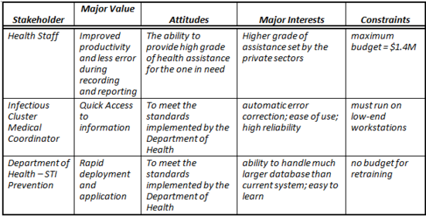

## Operating Environment

The Social Hygiene Clinic and Wellness Center Electronic Clinical Database for Sexually Transmitted Infection Prevention and Control Services will be deployed within one clinic in Paranaque in its initial launch to see whether the system will indeed improve the clinics overall performance and productivity. The system will only run locally and it will not be hosted or accessed online to further improve the security of the system as the records that it bears is considered confidential. The only way to know other patients record from different municipalities is by contacting their place of origin where the patient resides. As stated above that the system is only accessible locally, the patients’ records will only be generated on their place of origin or where they reside.

Purpose, Scope, and Objectives

**The project aims to:**  
1. To develop an electronic clinical database for STI services in Paranaque City.   
2. To decrease the number of hours spent in recording patient’s information by SHC staff by at least 50%.   
3. To decrease the number of hours spent by SHC staff by at least 50% in generating monthly, quarterly and annual reports.   
4. To decrease the waiting time of patients in availing STI services by at least 50%.   
5. To decrease the time exerted by health staff during retrieval of records of previous patients by at least 50%.

**Scope**

The Social Hygiene Clinic and Wellness Center Electronic Clinical Database project will be implemented in Paranaque City within the project period among patients and commercial sex workers working at night establishments, massage parlors, and other establishments alike. The project will only include information on the 3 basic services offered by the SHC including health center application, HIV voluntary counseling and testing and STI consultation.

System Overview

The development of the Social Hygiene Clinic and Wellness Center Electronic Clinical Database for Sexually Transmitted Infection Prevention and Control Services is being undertaken to improve the current system of recording and reporting in the facility which may directly impact on the quality of services offered by the clinic. Computerization of records will benefit the health staff as well as the client of SHC. Through faster retrieval of records of previous patients, health staff will be able to serve more patients in a given time. On the part of the patients, waiting time is expected to decrease and will eventually lead to a much satisfied customer of the facility. Patients or customers who are satisfied and rectified and received quality services are expected to follow-up regularly and comply with the requirements as stated in the Sanitation code. The more efficient recording system will also enable the facility to keep track of patients who are lost to follow-up.

The efficient recording system that may be produced by this project will also translate to a much better reporting of accomplishments. The project is expected to produce a more accurate report as compared to the old system of paper-based reporting. Timeliness of submission of report is also expected to improve since less time is now needed to prepare the report.

Contacts

**Name:**Darius J. Sebastian (Medical Officer V)

**Email:**darius_314@yahoo.com

Project References

Before the conduct of the project, a review of the existing Department of Health-Social Hygiene Clinic Manual of Procedure must be done. A training plan for Social Hygiene Clinic staff should also be done to augment the knowledge of health staff in using the new system

Relationship to Other Projects

The project has no relationship to other projects.

Organizational Interfaces

As stated above, the project has no relationship to other project; therefore, there is no organizational interfaces needed here.

## Acronyms and Abbreviation

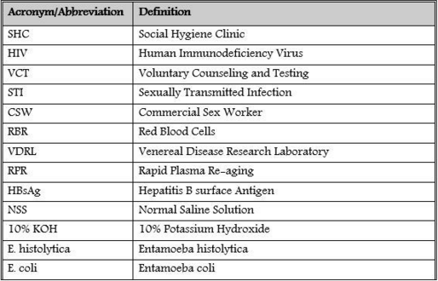

Planned Activities, Events, and Deliverable

The first goal of the Clinical Database and system that’s been developing is to improve the accuracy and efficiency of every data that they would gather. For starters, the system would drastically change the way how the Clinic's social workers would work. With the new database the way they store their data would be faster and would lessen the redundancy which is a common problem for the clinic. The system that we are developing is a low profile software that does not require the highest spec’s computers but it does not sacrifice security.

Roles and Responsibilities

**Project Manager** – responsible for the successful beginning of the project, plan, designs, implementation, managing and monitoring the project until the end of the project.   
**Project Developer** – responsible for giving an idea on how to construct the project.   
**Project Editor** – responsible for managing, creating, and printing the documentation of the project.

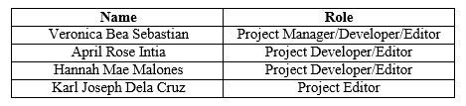

## Methods and Techniques

**Planning Phase**  
Gathering of ideas for the system that would further improve the system for the ease of use the Social Workers of the clinic.

**Analysis Phase**  
Creating diagrams to see a clearer view of the system. The system used Microsoft Visio to draw the diagrams that are needed for better understanding of the system.

**Design Phase**  
This one of the longest phases of the process in developing the system. We develop the codes for the system, finalizing all the requirements given. Sticking to the business requirements as we give life to the system. Using Microsoft Visual Studio as our main tool.

**Testing Phase**  
With this phase, the system has been scanned for possible errors for the system. By using the system with the other Social Workers for us to know on what other features that we may add to further improve the productivity of the workers.

**Implementation Phase**  
This is the part where the system will be used by the social workers. Feedbacks and comments are collected. from them in order to maintain 100% usability of the system.  
This is also a good source to know whether the system that we have developed is really a huge benefit for them.

**Maintenance Phase**  
This the part where we basically go back to planning and developing phase where we would know what to improve on and to address any existing problems.

## 

## Environment

The Social Hygiene Clinic and Wellness Center Electronic Clinical Database for Sexually Transmitted Infection Prevention and Control Services will be deployed within one clinic in Paranaque in its initial launch to see whether the system will indeed improve the clinics overall performance and productivity. The system will only run locally and it will not be hosted or accessed online to further improve the security of the system as the records that it bare is considered confidential. The only way to know other patients record from different municipalities is by contacting their place of origin where the patient resides. As stated above that the system is only accessible locally, the patients’ records will only be generated on their place of origin or where they reside.

**User’s Manual**

**Upon Log-In Page**

Once the user entered the his/her credential he/she will be then greeted with this page that contains all the identity information of the patient.

At the center part of this page with the blue background contains text fields for the Patient’s ID, first name, middle name and the like. It also features static field inputs for the date, date of registration and the patients’ occupation.

The bottom part of the page displays all the current patients that are stored in the database. On the upper side of table that displays all the current entry, a series of buttons are present for adding a new patient for saving new patient data for deleting records and for navigating through the records.

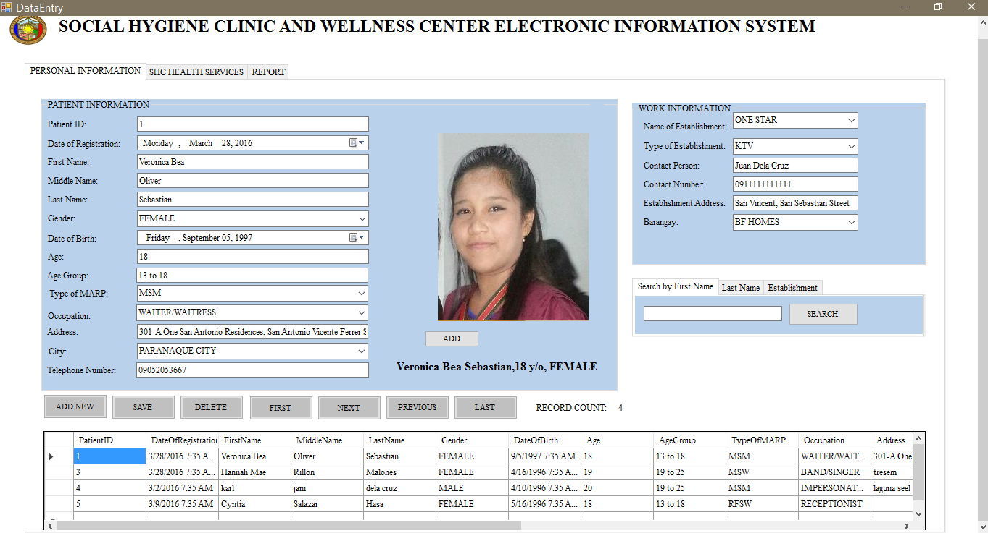

**Adding a New Record**

Once everything is all field up you will be greeted by a completion signal.

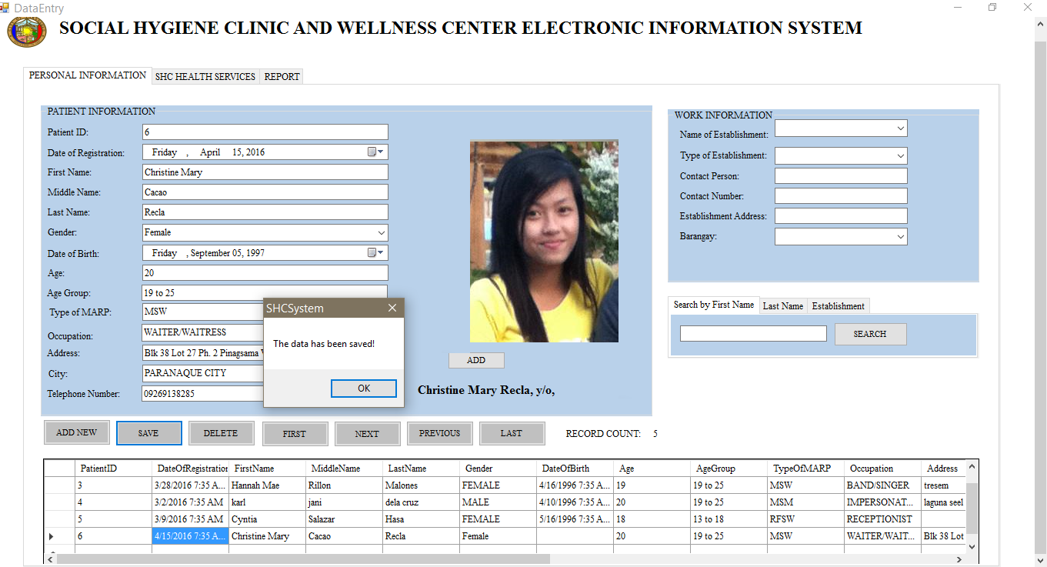

**Deleting of Data**

To prevent accidental deletion of patient entry there is a confirmation message to do so.

**Data Entry Pages**

Under these series of Data Entry pages features all the three different services that the Social

Hygiene Clinic offers

Under the SHC Health Services tab you will see all the three different health services that the

Social Hygiene Clinic offers which is STI Consultation, Health Certificate Application and Renewal

And HIV-VCT.

Each services tab contains the name, age and gender of the patient applying to keep track on what type of service he/she is in for. On the right side of the page features a table of history of the current patient for easy tracking. Each of the three pages’ features text fields and static data fields for easy data encoding.

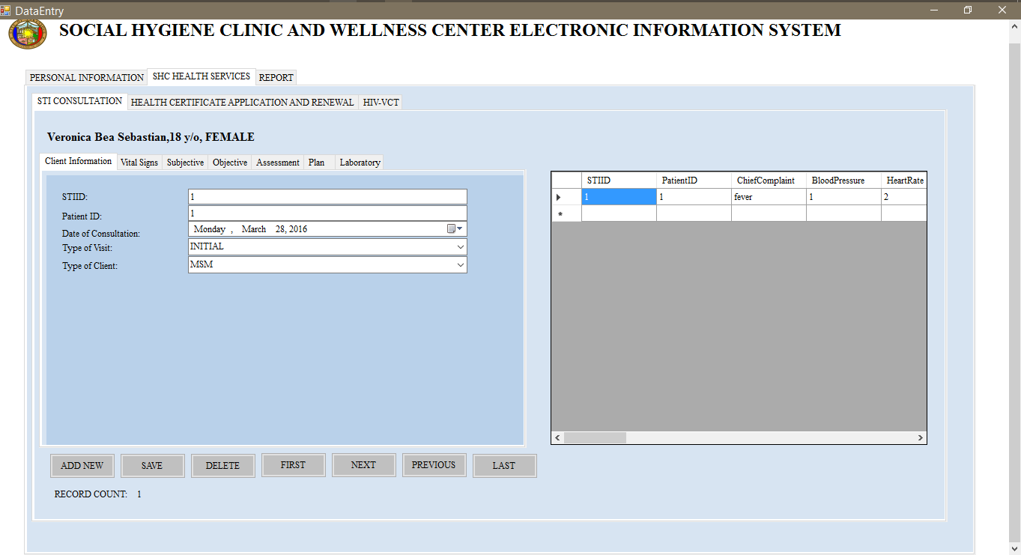

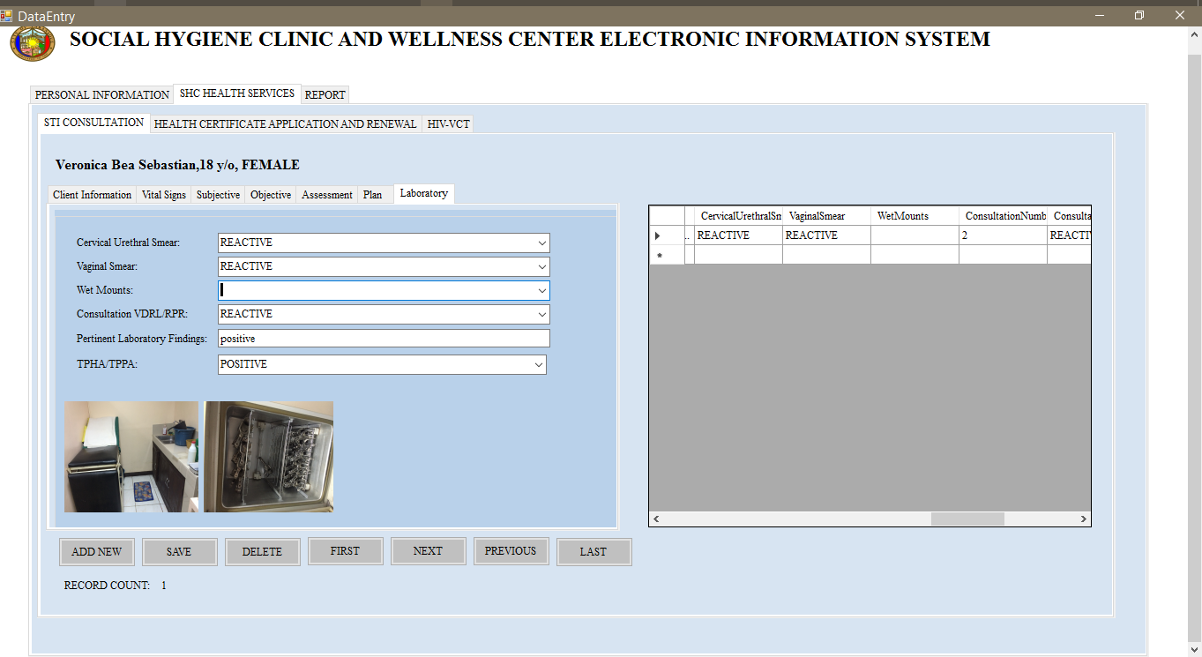

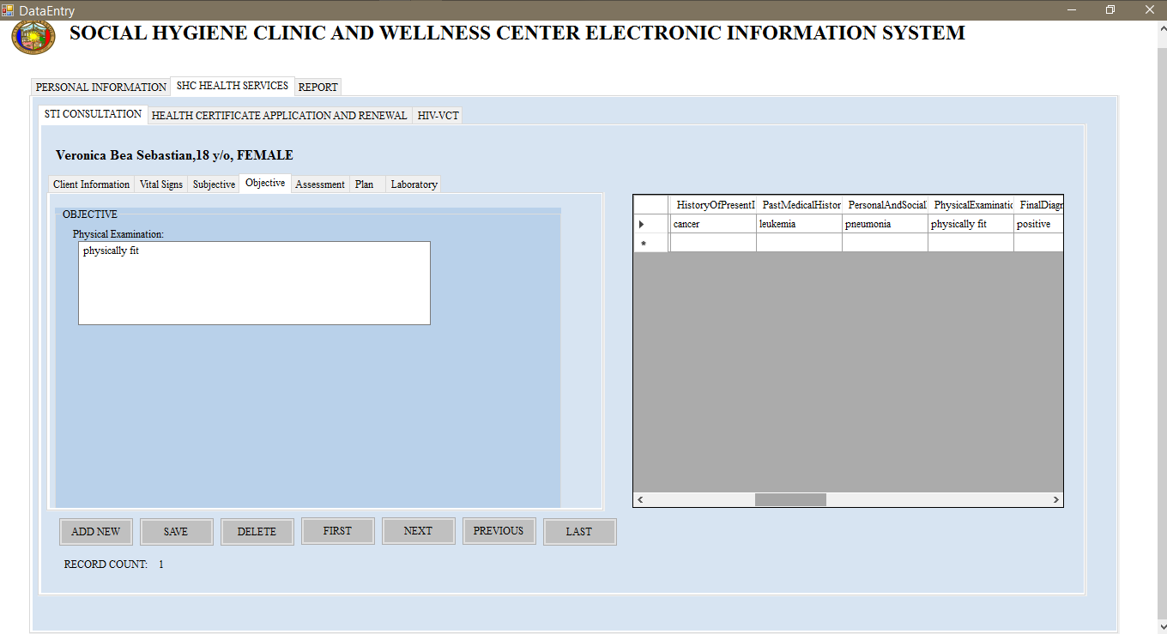

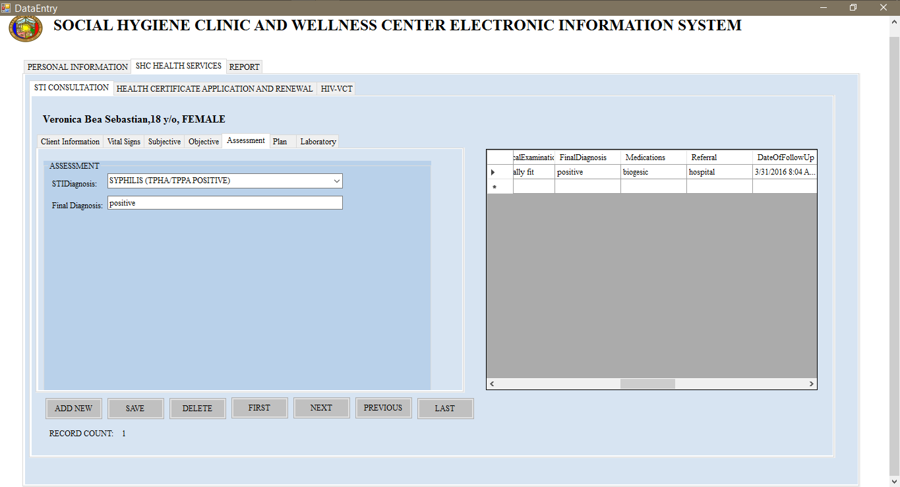

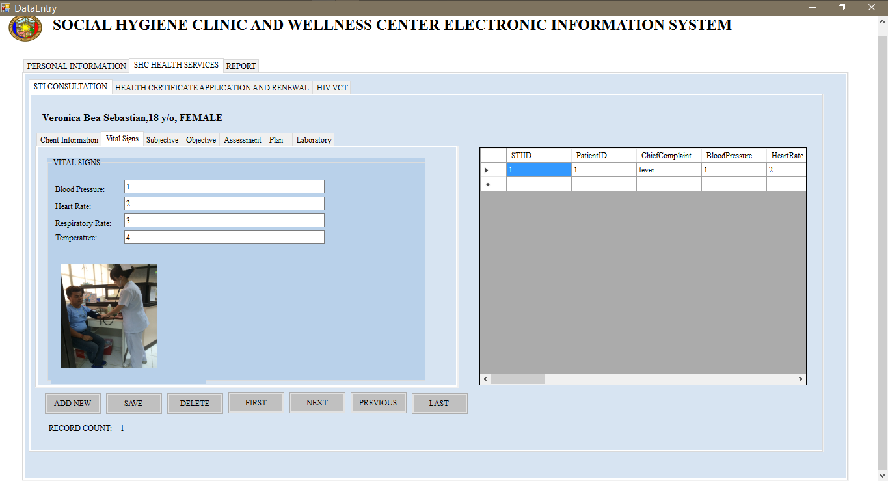

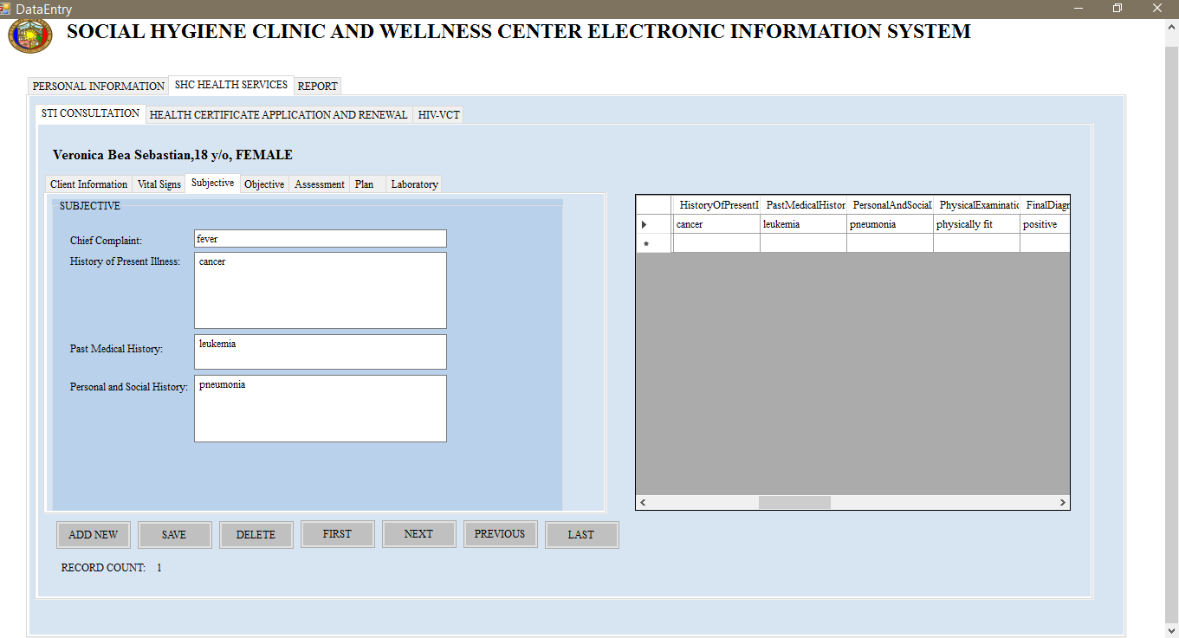

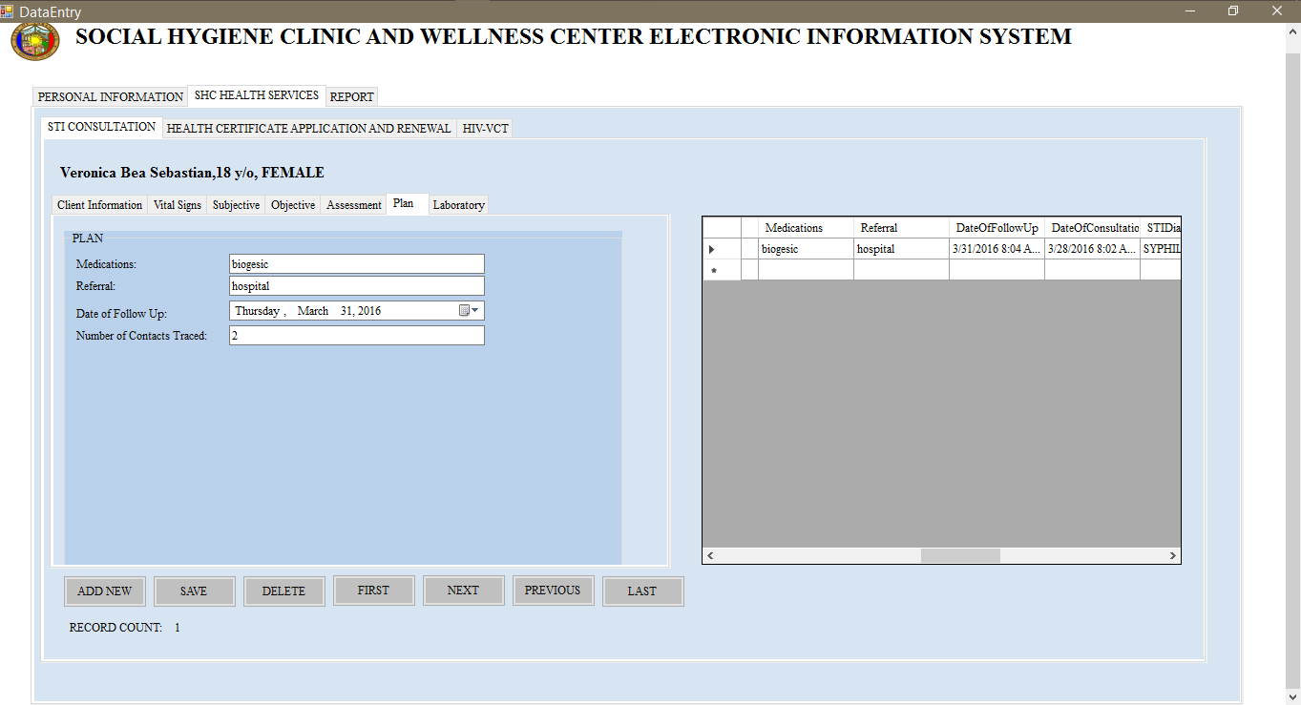

**Health Certification Page**

This page features tables and text fields and static drop down menus for various selection of information needed for each patient. On the left most part of the page features a table that saves all the records that the patient injured during his/her visit. There are several buttons on the lower part of the page for adding a new record for saving the record, deleting and navigating through the records. For every page there is

a number count of records for each patient and services taken.

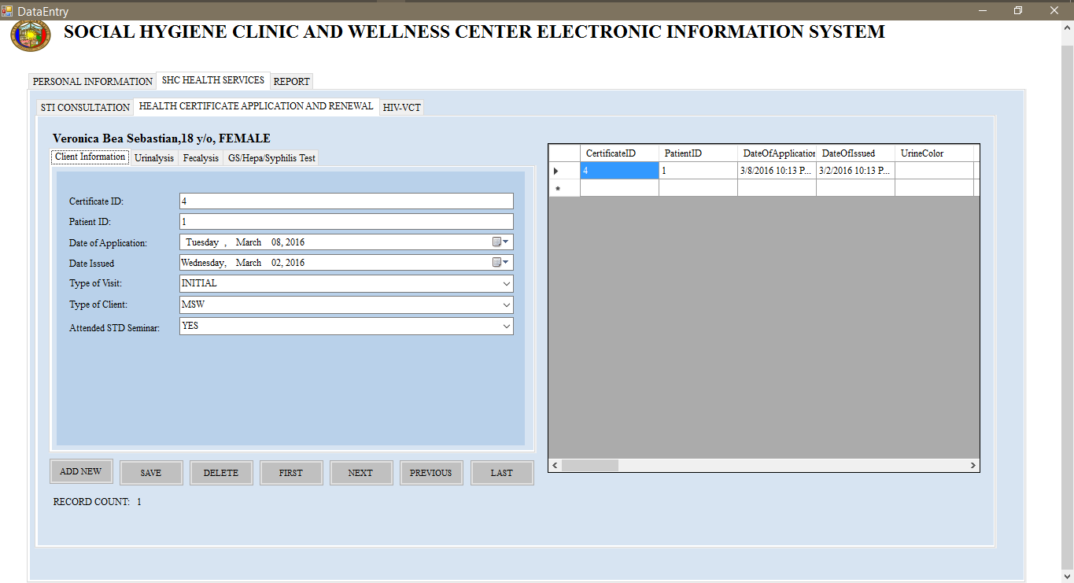

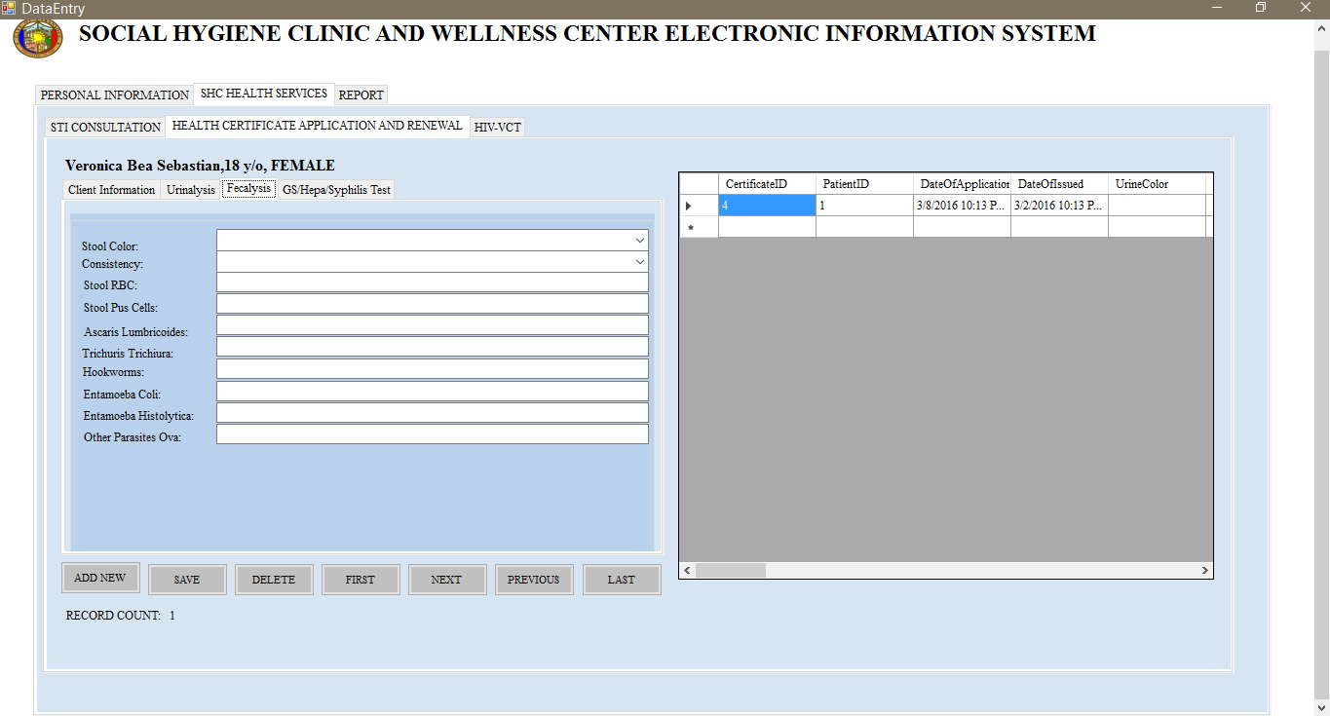

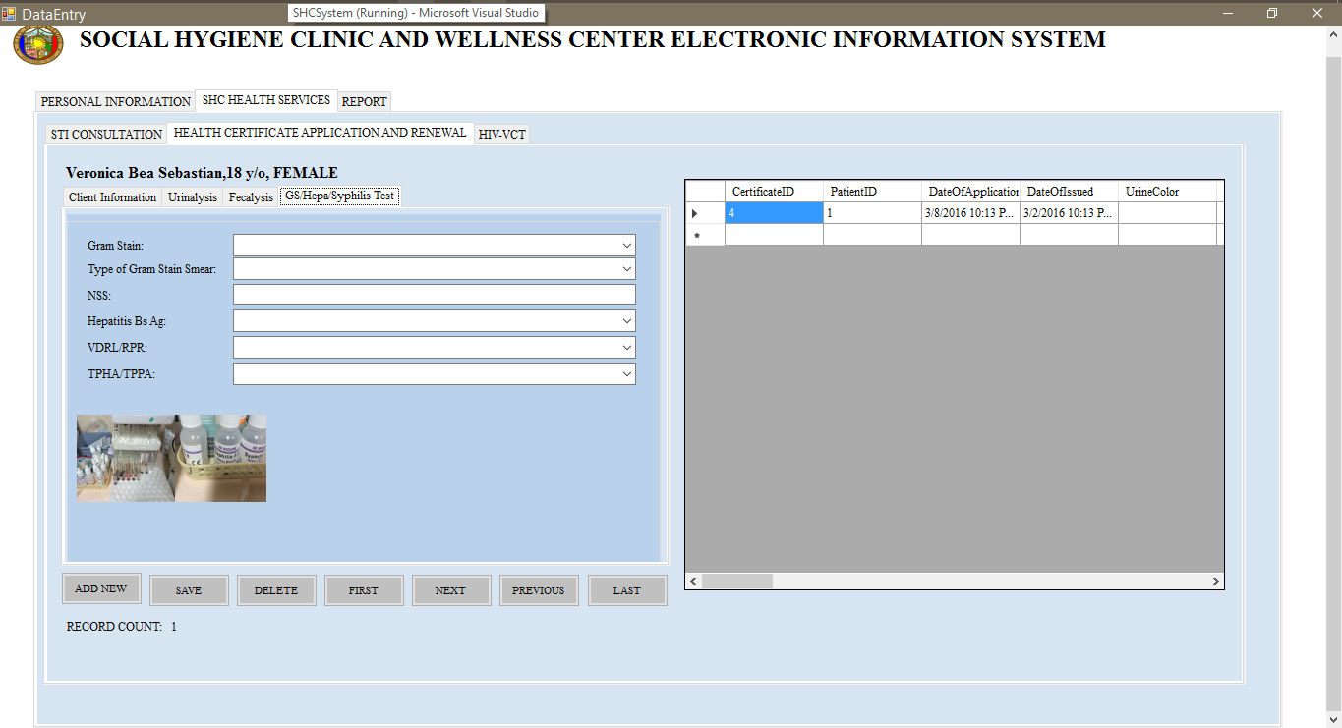

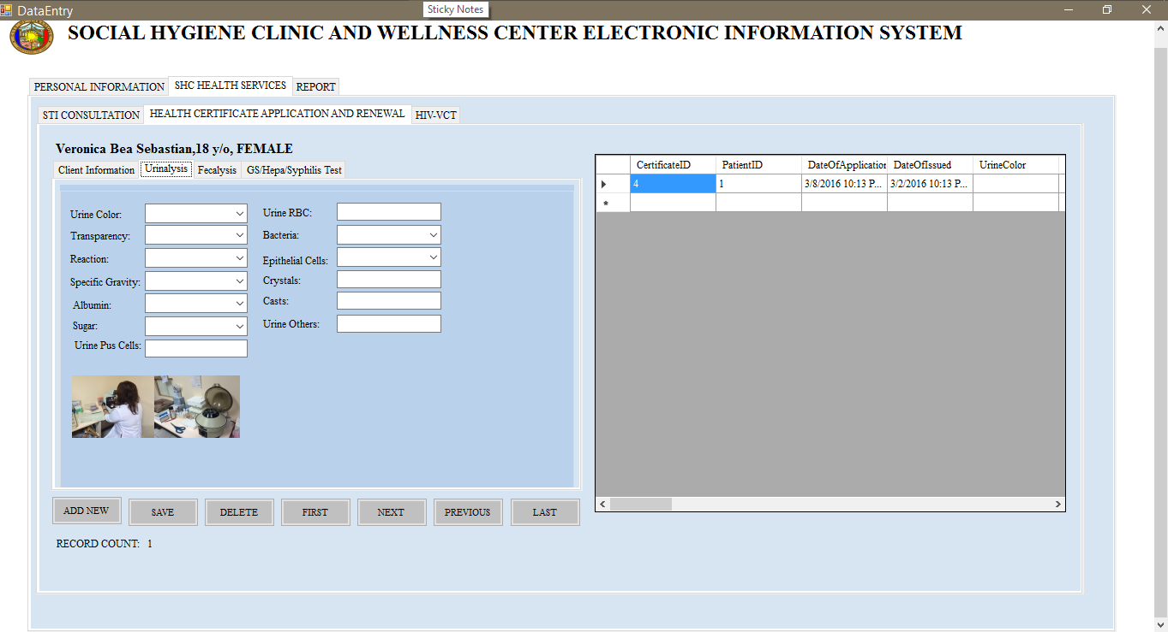

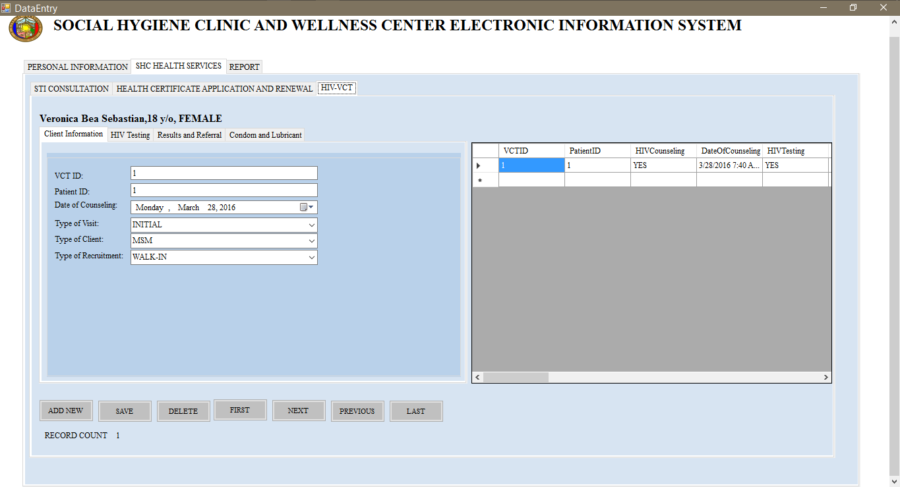

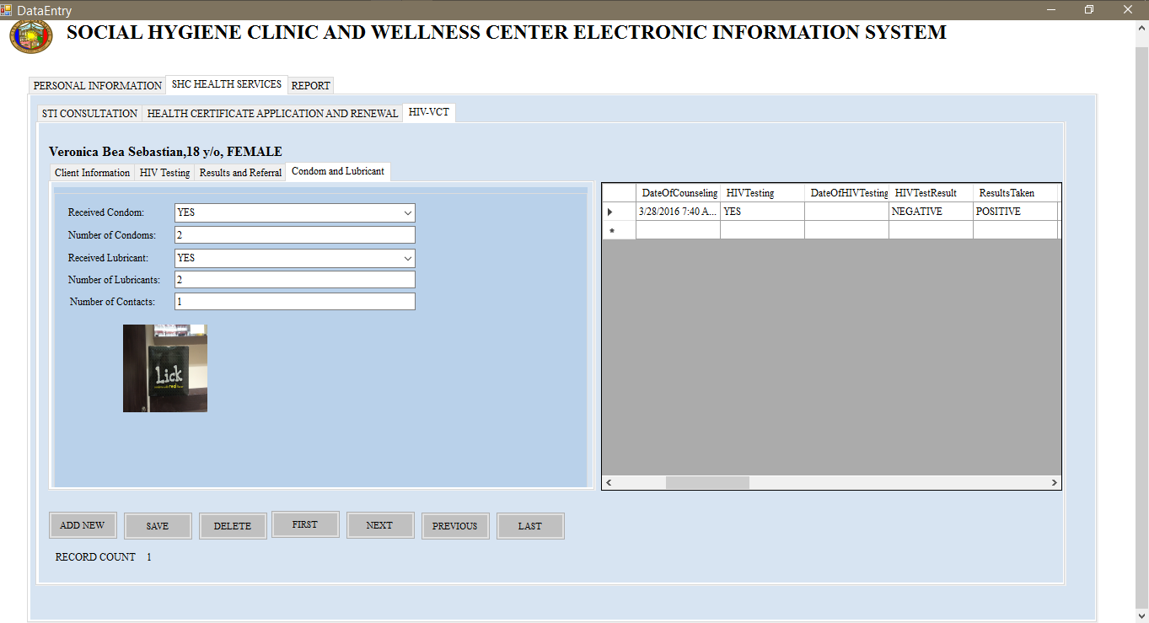

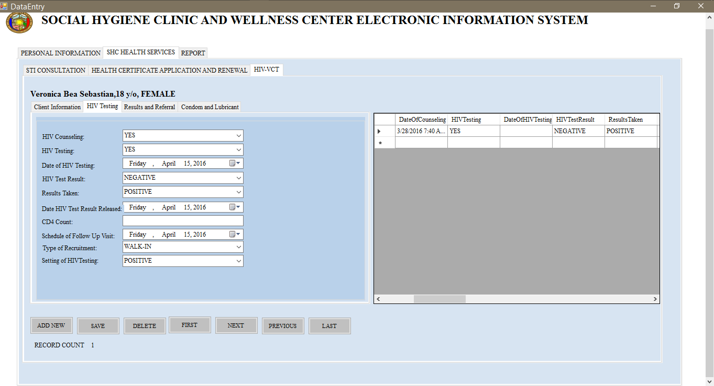

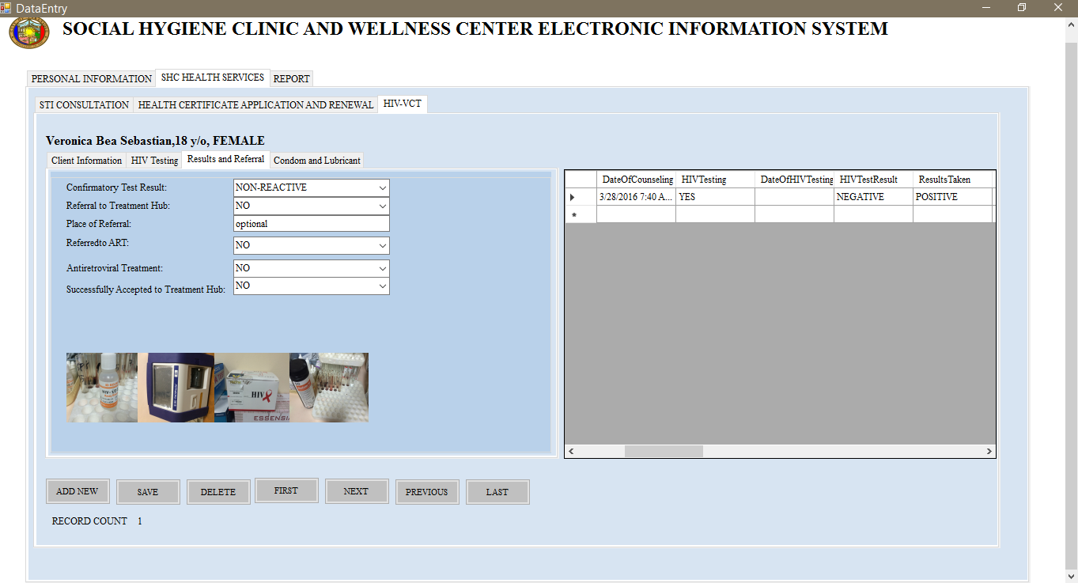

**Report Selection Page**

This page features all the kind of reports that the Social Hygiene Clinic would need for easy report extraction to be sent to the Department of Health for statistics purposes.

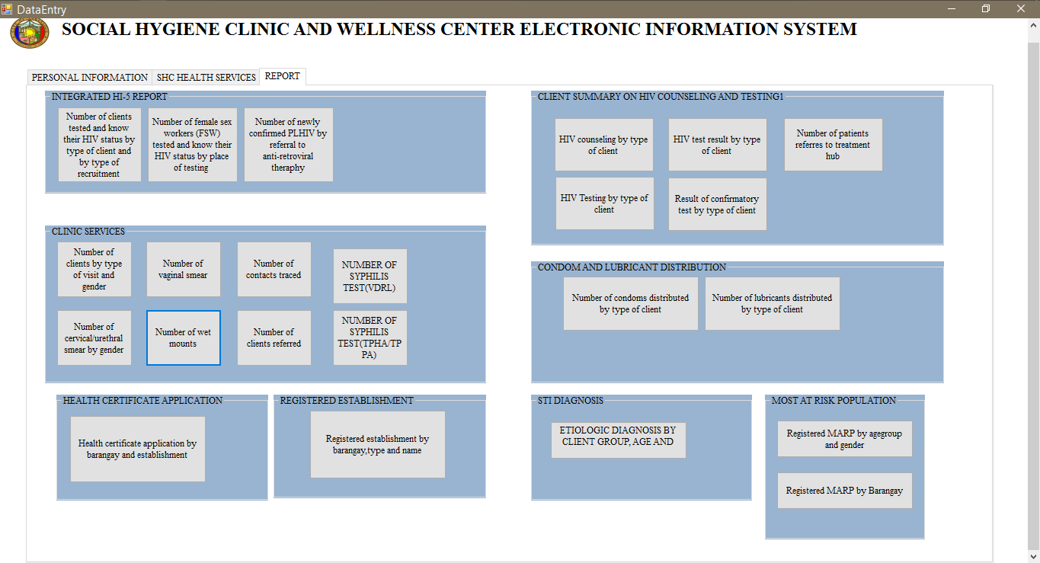

**Report Table Page**

On this page contains the different report table for easy tracking of what type of services are

being served to patients. On the upper left corner of every table report screen features a calendar date selection to see the exact amount on a certain day. There are also and addition of filter

button and reset button. On the upper center of the screen features a home button that brings

you back to the main page of the system.

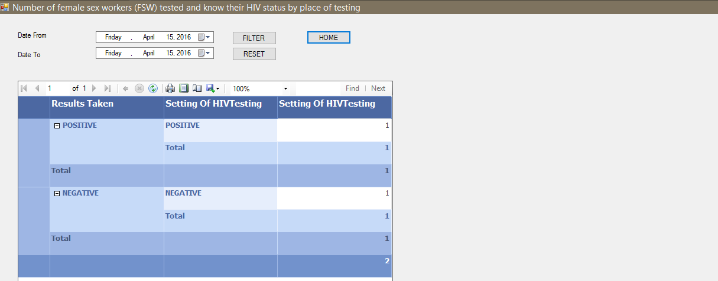

**Diagrams**

**Activity Diagram for Health Certificate**

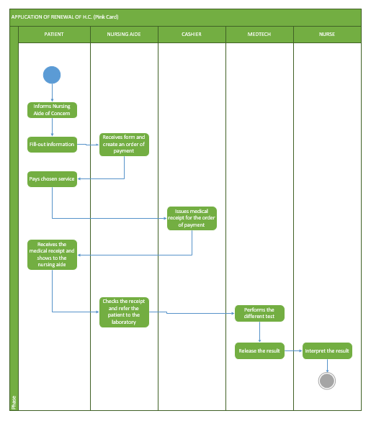

**Activity Diagram for STI**

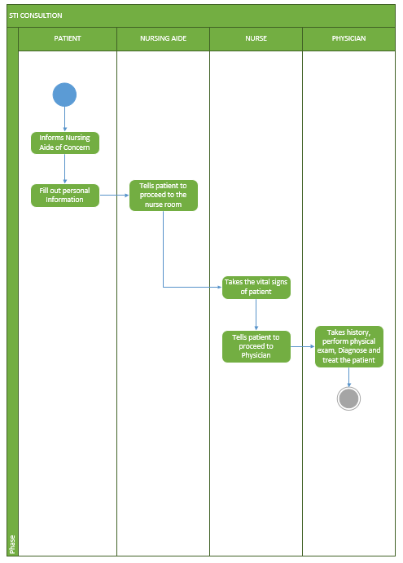

**Activity Diagram for HIV Voluntary Counselling and Testing**

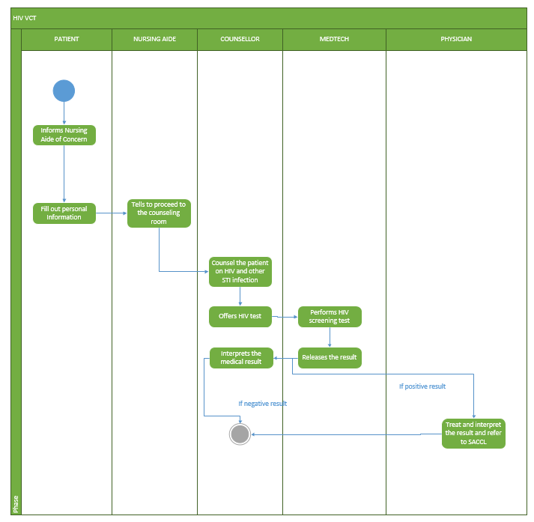

**Class Diagram**

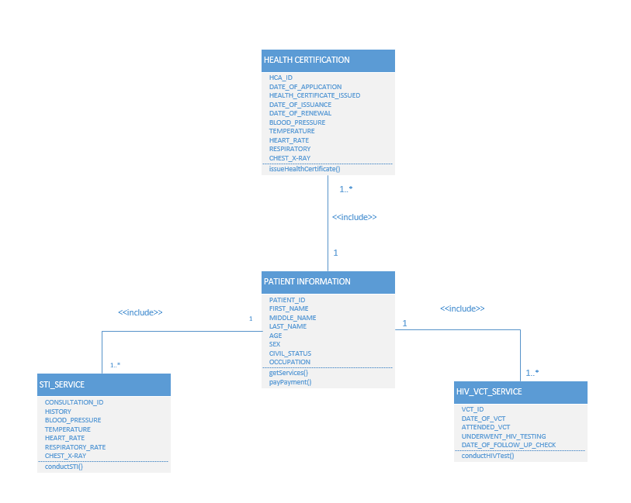

**Sequence Diagram for not Existing Patient**

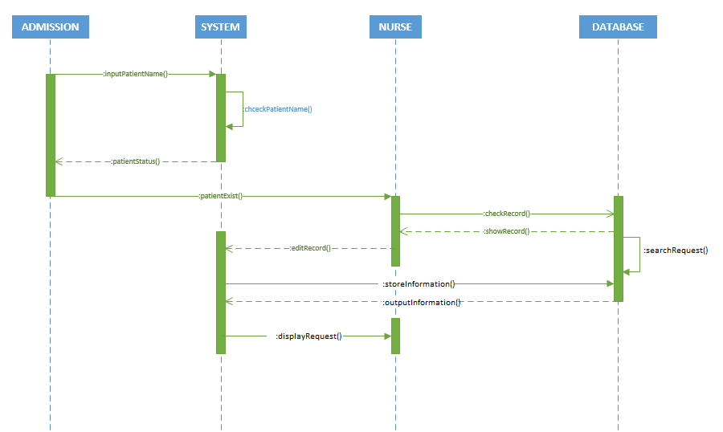

**Sequence Diagram for Existing Patient**

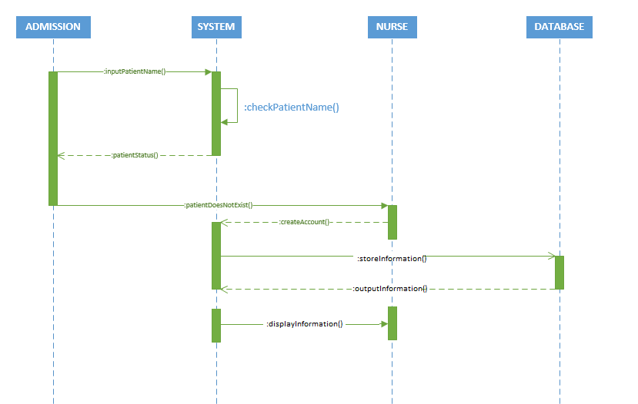

**Use Case for HIV Voluntary Counselling and Testing**



**Use Case for STI**

C:\Users\Karl\Desktop\School Works\3rd Year\2nd Term\SYSADD1\Re-Defense Files\Wiki Files\USE CASE STI UPDATED.png

**Use Case for HIV**

**sC:\Users\Karl\Desktop\School Works\3rd Year\3rd Term\CSPROJ\Required Diagrams\USE CASE HIV UPDATED.png**